**Setup Docker Swarm on AWS using Ansible & Terraform**

**Pre-requisites:**

* Take AWS Linux Machine
* Install Terraform
* Install Ansible
* Install Git

**Install Terraform:**

wget <https://releases.hashicorp.com/terraform/0.11.14/terraform_0.11.14_linux_amd64.zip>

unzip terraform_0.11.14_linux_amd64.zip

cp terraform /usr/bin

terraform --version

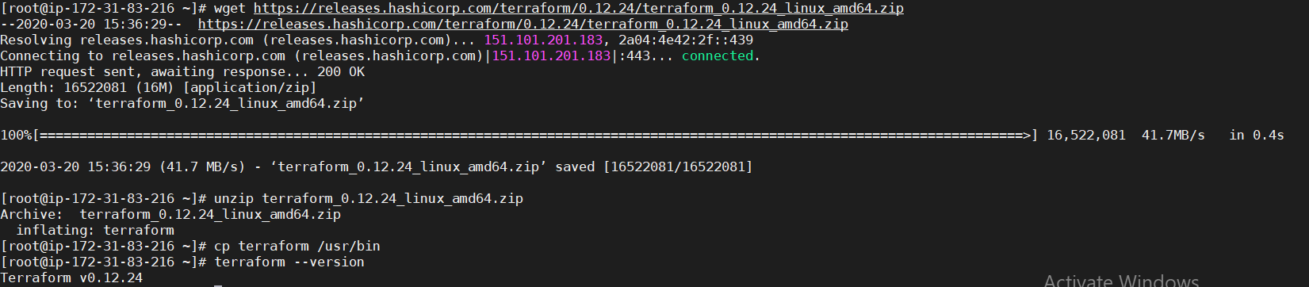

**Install Ansible:**

Install Ansible into this server

wget <http://dl.fedoraproject.org/pub/epel/epel-release-latest-7.noarch.rpm>

rpm -ivh epel-release-latest-7.noarch.rpm

yum repolist

yum install ansible -y

ansible --version



**Install Git:**

yum install git -y

**Generate a key for SSH:**

ssh-keygen

**Clone Terraform code for docker swarm setup:**

git clone <https://github.com/mlabouardy/terraform-aws-labs.git>

cd terraform-aws-labs/

cd docker-swarm-cluster/

**Docker-swarm master-node setup using terraform:**

terraform init

terraform plan

terraform apply